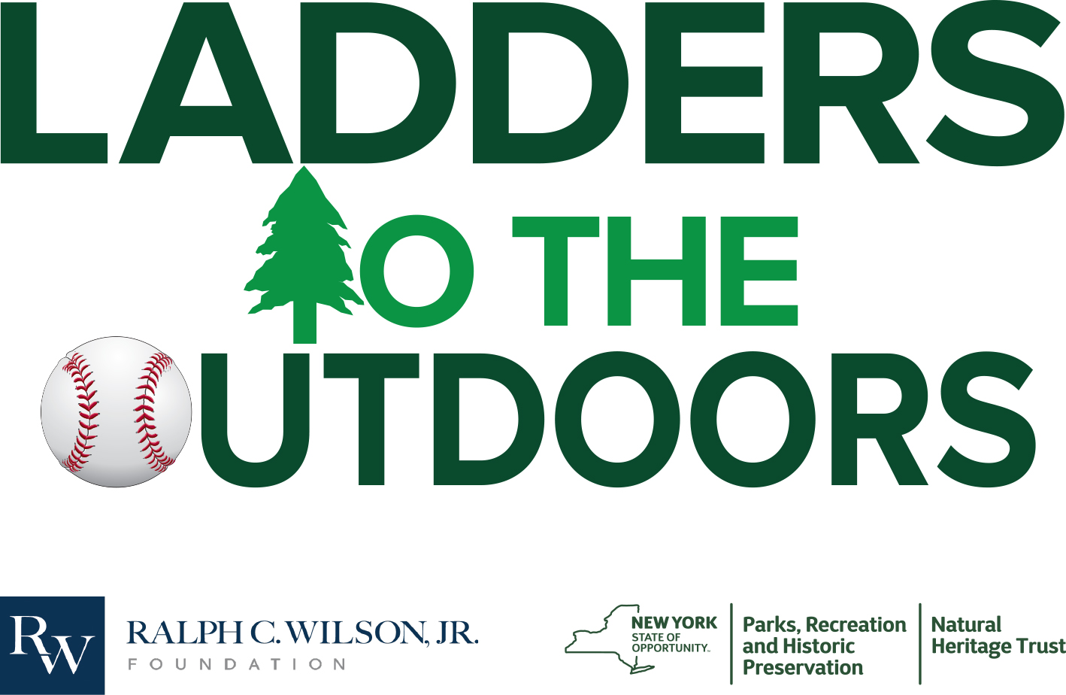

“Connecting Kids to State Parks”

KeJuan Harmon(Coordinator)
KeJuan.Harmon@parks.ny.gov
(716)225-0389

Ladders to the Outdoors Mission Statement

Ladders to the Outdoors is a community outreach organization funded by the Ralph C. Wilson Foundation and executed through New York State Parks that will connect youth from the region’s underserved communities to the unique and historic New York State Parks in Western New York. Ladders to the Outdoors will work closely with school districts, corporate partners, and the many local youth organizations to offer programming and activities to help connect kids with state parks, nature and foster a lifelong love of the outdoors.

While this document suggests programs that are already in place, please feel free to ask about other opportunities that may be of interest to your group and we can work together to try and make it happen. The parks belong to you! We are here to connect you to them.

Program Overview
- Learn to Bike
  - Learn to Bike, will teach kids how to properly ride a bike and understand the importance of safety equipment when riding a bike.
- Learn to Fish
  - Learn to Fish will teach kids the fundamentals of fishing as well as educate them on fishing and the proper equipment that is required to fish.
- L.T.O Days at the Park
  - LTO Days at the Park will offer space and equipment for groups or schools to use for recreational based field days.
- Learn to Swim
  - Learn to Swim will teach kids how to safely swim and appreciate the joys --and dangers-- of being in the water.
- Learn to Kayak
  - Learn to Kayak will teach kids how to safely navigate waters in kayaks.
- Hiking
  - Hikes along the rim from Whirlpool State Park to the Devils Hole offer beautiful views of the Niagara Gorge. Guided hikes will be available based on availability. Be mindful of difficulty levels of hikes into the Gorge.

Buffalo Harbor State Park
Address: 1111 Fuhrmann Blvd Buffalo, NY 14203
Website: https://parks.ny.gov/parks/buffaloharbor/details.aspx
Buffalo Harbor State Park is the first state park in the city of Buffalo. Boasting beautiful views of Lake Erie, the park is home to a 1,100-slip marina, a restaurant, boat launches, personal watercraft launches, fish cleaning station, restrooms, and a beach for strolling and sunbathing, and a nautical themed playground great for kids of all ages.
.

Programs at Buffalo Harbor
- Learn to Bike
- Learn to Fish
- L.T.O Days at the Parks

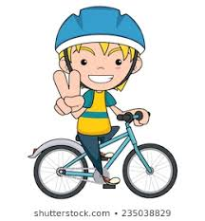
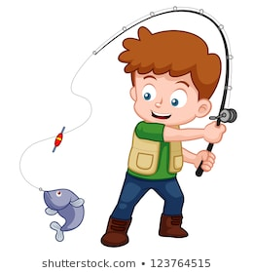

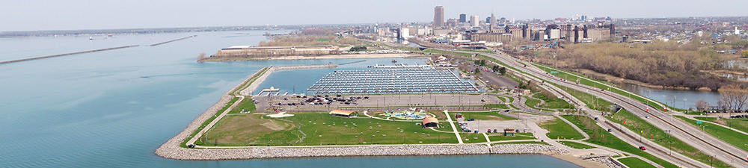
Beaver Island State Park
Address: 2136 West Oakfield Road Grand Island, NY 14072
Website: https://parks.ny.gov/parks/beaverisland/maps.aspx

Beaver Island State Park is located at the south end of Grand Island in the upper Niagara River. The 950 acre park has a half-mile sandy beach for swimming, adjacent 80 slip marina with both seasonal and transient boat slips, fishing access, car-top boat launch, multiple canoe/kayak launches, bike and nature trails, nature center, playgrounds, picnic areas, athletic fields, horseshoe pits, an 18 hole championship disc golf course, an 18-hole championship golf course.

Programs at Beaver Island
- Learn to Fish
- Learn to Kayak
- Disc Golf Program
- L.T.O Days at the Park
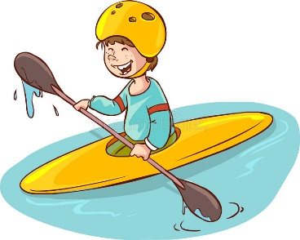
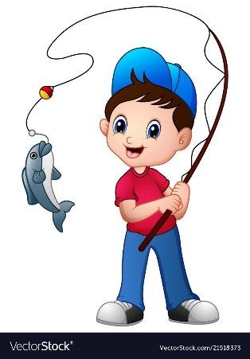

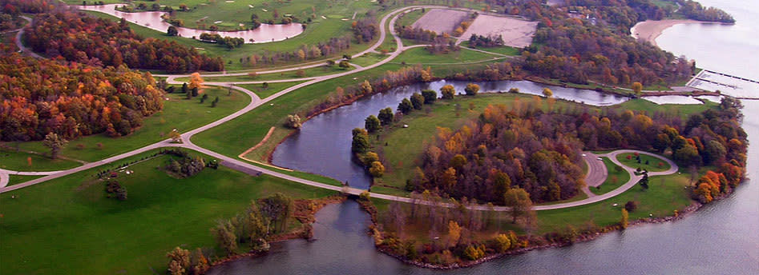

DeVeaux Woods, Whirlpool and Reservoir State Park
- DeVeaux Woods: (3180 De Veaux Woods Drive Niagara Falls, NY 14305)
      - Website: https://parks.ny.gov/parks/deveauxwoods/details.aspx

- Whirlpool: (Niagara Scenic Parkway Niagara Falls, NY 14303)
      - Website: https://parks.ny.gov/parks/105/

- Reservoir: (5777 Witmer Road Niagara Falls, NY 14304)
  - Website: https://parks.ny.gov/parks/75/details.aspx

- DeVeaux Woods State Park has a baseball diamond, a signature playground, picnic facilities, nature trails through a meadow and Old Growth Woods, and a path that leads across the Niagara Scenic Parkway to Whirlpool State Park with access to the Niagara Gorge trail system.
- Whirlpool State Park has many scenic overlooks with spectacular views of the Whirlpool and rapids. Trailheads lead into the Gorge where challenging trails lead to one of the most spectacular landscapes in the country. There are also picnic facilities and a playground in this park.
- Reservoir State Park has two tennis courts, seven softball diamonds, four basketball courts, a roller hockey court and picnic facilities

Programs offered at these parks
- Baseball Instruction
- Learn to Hike
- LTO Days at the Park
Fort Niagara State Park
Fort Niagara State Park has two boat launches providing access to the Lower Niagara River and Lake Ontario, woodland hiking trails, a swimming pool, a view of Lake Ontario, picnic grounds, playgrounds and 18 soccer fields.

Programs at the Parks
- Learn to Swim
- Soccer clinics in connection with Pioneer Soccer league

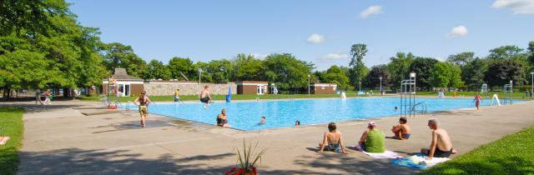
Wilson-Tuscarora State Park

Wilson-Tuscarora State Park is a well-preserved natural area for many varieties of plants and wildlife, encompassing 476.5 acres of mature woods, open meadows and marshland. Tuscarora Bay, divided from Lake Ontario by a strip of land called "The Island," has a boat launch and emergency storm shelter docks. The park's four-mile nature trail is also used for hiking, snowshoeing and cross-country skiing. Fishing for many varieties of pan fish and game fish, from boats or from shore, is extremely popular.

Programs at the Park
- Learn to Kayak
- Learn to Fish
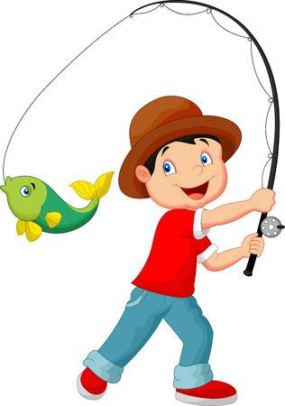
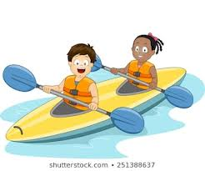
- L.T.O Days at the Park

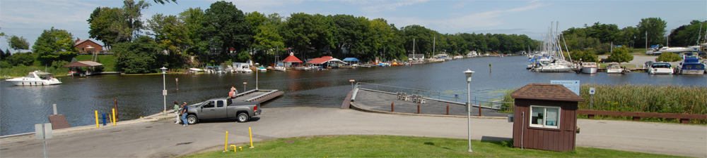
Ladders to the Outdoor Group Registration
- You can also fill out an online form, just click here…
Group Name: _____________________________________________________
Group Leaders: ___________________________________________________
Address: _________________________________________________________
City: ______________ St: ________________ Zip ________________
Phone: ___________________ Email: _______________________________
Date of Event________________________
Start Time of Event: ________________ End Time of Event______
State Park Being Used: _____________________________________________
What activities do you plan to do while visiting?
Learn to Bike ____
L.T.O Days at the Park____
Learn to Kayak___
Learn to Hike _______
Learn to Swim _______
Learn to Fish_________
Other (Let us know what YOU want to do!) _______________________________
Group Information (If you don’t know yet, please estimate)
Number of children that will be in attendance ________________
Will any parents be attending? if so, how many? _________
Do you need Connect to Kids Transportation Yes _____ No______
If yes, click here or visit
https://survey123.arcgis.com/share/469f6fec9f904c18a755b1352bae745e to apply.

